Name: Muhammad Usman Khan
Saylani Mass IT Program
Course: Data Science and AI (Batch 9)
Id: AI-450271

Table Of Contents
Introduction: 3
Objective: 3
Health Care Data Set: 4
Data Pre-Processing: 5
Data Visualization and Analysis: 5
Univariate Analysis: 5
Bivariate Analysis: 5
Insights and Conclusion: 5
Tools Used: 5

Introduction:
The project is focusing on analyzing health care data set to understand the relations that may contribute to Stroke occurrence.
The following analysis extract using libraries like Pandas, NumPy, Matplotlib, Re and String. I performed Data cleaning, statistical analysis and visual representation to extract meaningful insights and relationships between one and each feature.

Objective:
The main objective to perform this data visualization:
- To perform data cleaning find out missing/null values and fill them.
- To apply tabular data visualization and to extract information like mean, median, mod, min, max, standard deviation etc.
- To represent data like age on bar charts
- To represent relationships between each feature by using scatter plot and histograms

Health Care Data Set:
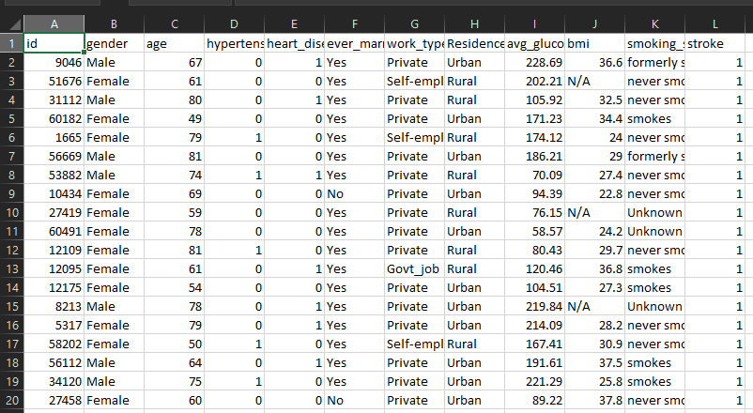
The data set Is a data set of health care data and contain information about various patients including their health conditions and stroke status.
Each row represents a patient’s record. Each row contains:
- Gender: Patient’s gender (Male, Female or others)
- Age: Age of the patient
- Hypertension: if the patient has hypertension, if yes 1 otherwise 0
- Heart disease: if the patient has heart disease, if yes 1 otherwise 0
- Ever married: Marital status (Yes / NO)
- Work type: Employment category
- Residence type: Patient’s residence
- Average glucose level: patient’s average glucose level in the blood
- Bmi: Patient’s Body Mass Index
- Smoking status: if the patient smokes or not
- Stroke: Target variable, if yes 1 otherwise no

Data Pre-Processing:
Data Pre-processing using the following steps:
- Load Data using pandas.read_csv()
- Checked data summary using .info() and .describe()
- Filled missing values in bmi columns using mean
- Dropped the id column which is not useful for our analysis
- Transform column names to lower case

Data Visualization and Analysis:

Univariate Analysis:
- Plot histogram on age, bmi, average glucose column which shows the frequency of each age group
- Pot pie chart on gender column to represent the male / female percentage

Bivariate Analysis:
- Plot scatter Plot using two features (age and average glucose level)
- Plot scatter Plot using two features (age and BMI)
- Plot histogram graph using two features (stroke and average glucose level)
- Plot histogram graph using two features (stroke and age)
- Plot histogram graph using two features (stroke and bmi)

Insights and Conclusion:
- Older age and high glucose level are the strongest indicators of stroke risk.
- Smoking and hypertension also appear related but less strongly.
- Preventive healthcare should focus on monitoring glucose levels and managing blood pressure in older adults.

Tools Used:
- python
- Pandas NumPy for data cleaning & analysis
- Matplotlib for visualization

